**Social History of The United States in the Antebellum Era**

**Questions**

* How did American life change in the closing decades of the antebellum

**The North during the Antebellum Era**

**Extreme economic growth**

* Abundance of natural resources
  + Iron was abundant along with having a large population to work for the country
* Transportation revolution
  + More people were creating roads connecting cities to cities
* Railroads
  + Not on a national basis
  + Private companies developed the railroads
    - At the expense of the Native Americans
  + Much more intense in the Northwest rather than the South

**New class formations**

* Industrialization created an urban working class and an urban middle class that in turn shaped gender roles

**Telegraph**

* Samuel Morse: created Morse code

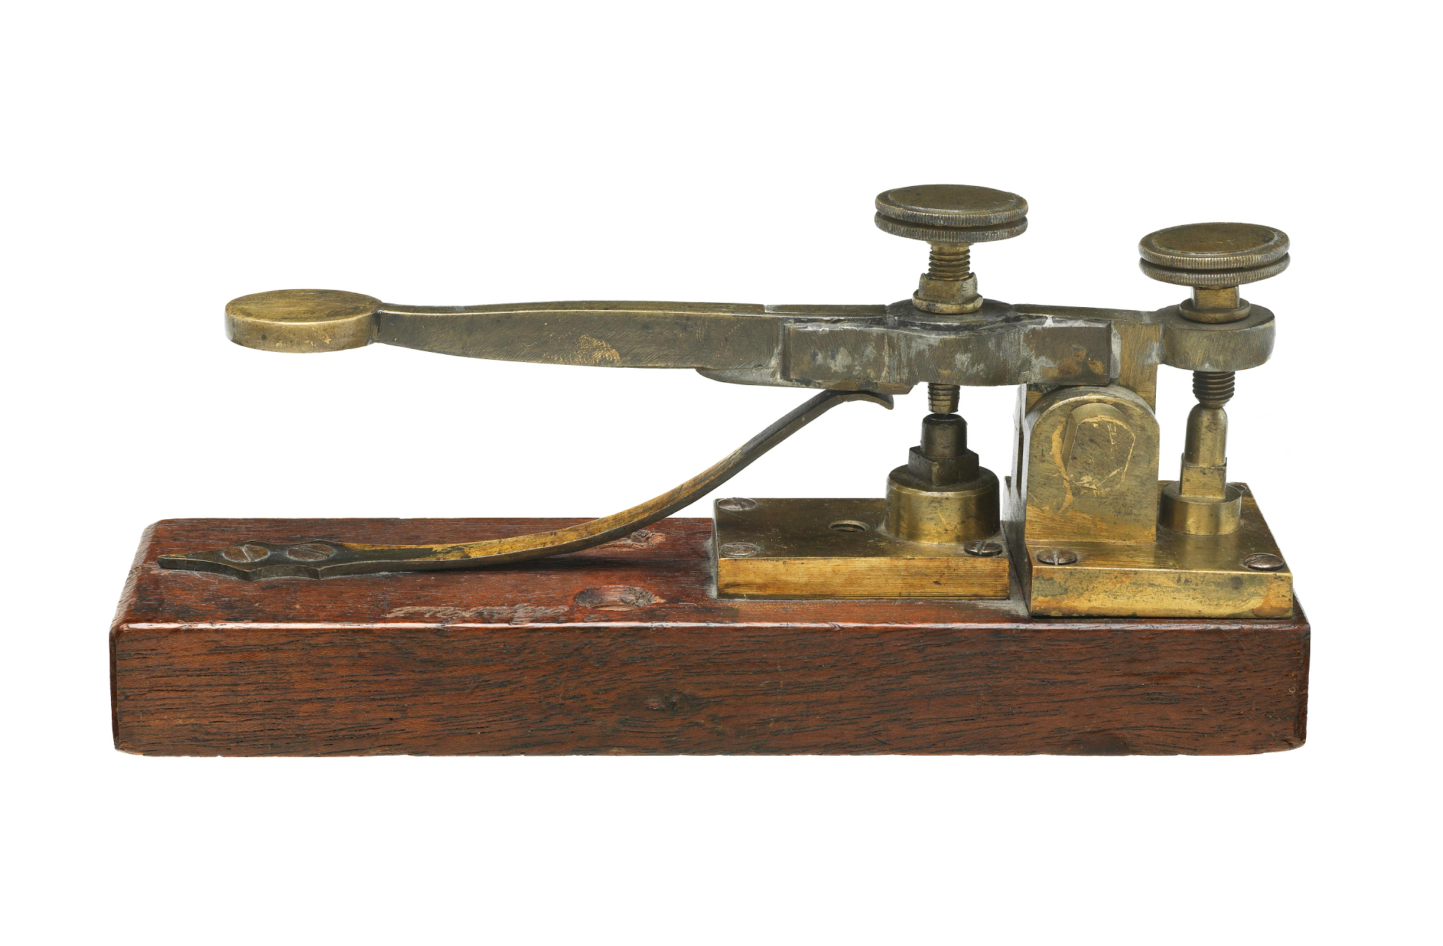

**Merchant/Investing Class**

* Celebrated independence, proclaimed success
* If you were successful, you were a self-made man
  + American dream, individualism, self reliance
* People become the new middle class
* Contribute to infrastructure

**Mechanical Aptitude**

* Americans are good at using the technology made and improved upon it

**Education**

* You can sharpen your mind
* Widespread in the northeast
* Schools were taught upon memorization
  + This is something that is not taught in modern school’s have lost
* Horace Mann: educational reformer inspired by the work of the Whig dedicated to promoting public education.
  + Made people financially viable in the job market
* They started looking towards women’s education
* Women’s colleges
  + Oberlin College
  + Mt. Holyoke
  + Vassar
* Women become teachers
  + They are then underpaid
  + Male teachers are then let go to make way for new teachers
* Irish Sentiment
  + Catholicism
    - Bringing back something they wanted to get rid of
* Putting out system
  + Lowell System
  + People would do one part of a larger production line
* Francis Cabot Lowell
  + 1775 to 1817
  + Instrumental in developing the first integrated mill in the US
  + Father of Industrial Revolution in US
  + Provided housing for the women who he worked for and education as well

**Middlesex Company Woolen Mills**

**Rise of a Working Class**

* In the 1830s and 1840s, workers began to unionize for greater leverage with employers
* Middle class values
  + Properly dressed ladies
  + Family values
  + Being able to play an instrument
    - Forced to be a pianist
* Women occupy a different sphere
  + Called separates spheres
  + Private sphere
  + Two of them should not ever meet
* Men
  + Public Sphere: women only stayed at the house and cleaned and whatnot
* Enlightenment Ideals
  + Women are naturally supposed to be mothers
  + Women were “delicate” creatures
  + Cult of domesticity
  + Considered to be innocent
  + Asexual
    - Women “should not” have sexual pleasures
  + Men were to protect the women
    - Should be able to provide for your family
* These ideas do not apply to non middle class people

**Tredegar Iron Works**

**Southern Social Hierarchy**

* Planter Aristocracy
* Small planters
* Not all planters were seen as the same

**Southern Womanhood**

* Often used to justify paternalism on the part of planters

**Poor Whites**

* Did not own land or slaves, but could vote starting in the 1830s
* Class antagonism often diffused by racial antagonism
* Northern stereotypes called them “white trash, “hillbillies”, “rednecks”, “crackers”

**Movie Notes**

**Link to watch:** <https://www.youtube.com/watch?v=vuOaTwuzlrY&has_verified=1>

* Man taught himself how to write using blackberries that he got as food
* He was once a successful violin player
  + Tricked into being sold into slavery by two white dudes
  + T